**Bug Report**

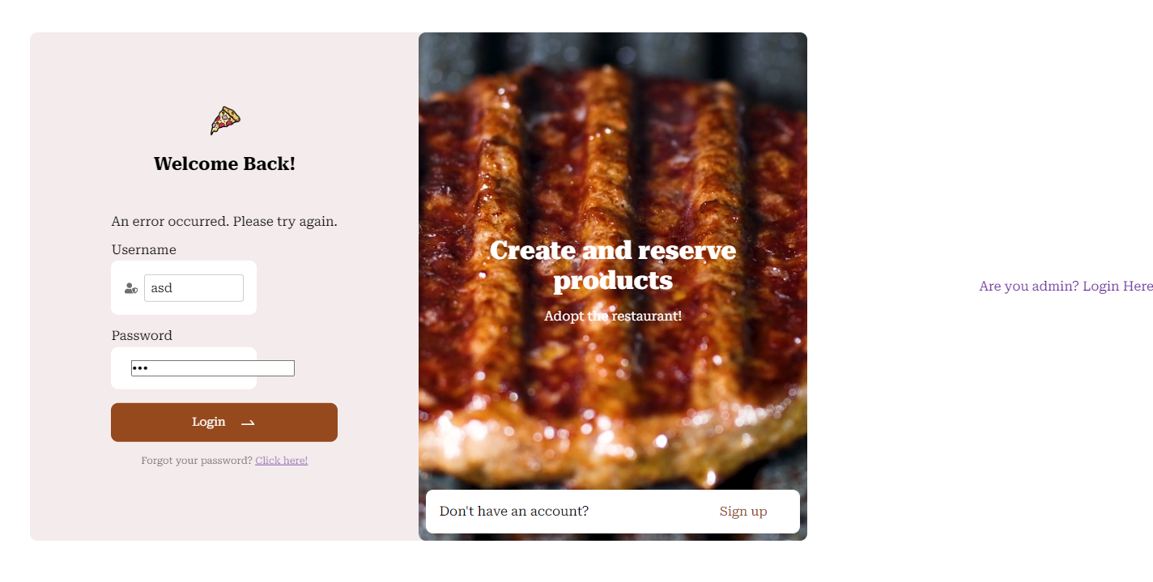

Be more specific on the comment saying Invalid username or Password.

Keep the are you admin Login here inside the div and make it presentable.

When the user registers there needs to be an alert message saying you have successfully registered.

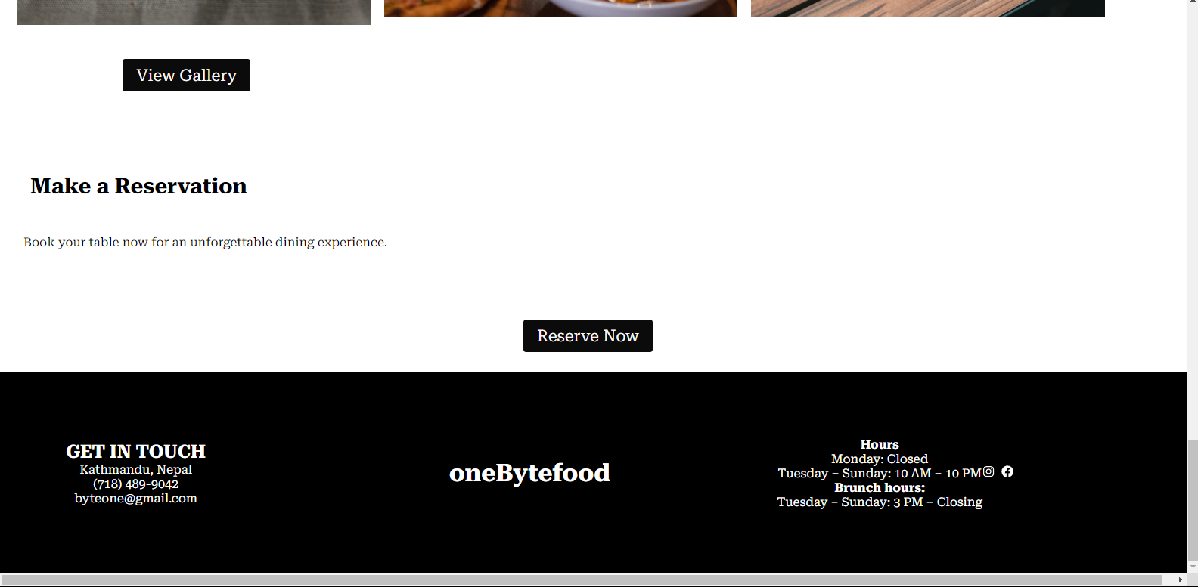

Fix the view gallery button and keep something in the reservation section for a more presentable approach.

Fix the footer section as well.



Even though the username is wrong the reservation still takes place. Fix that.

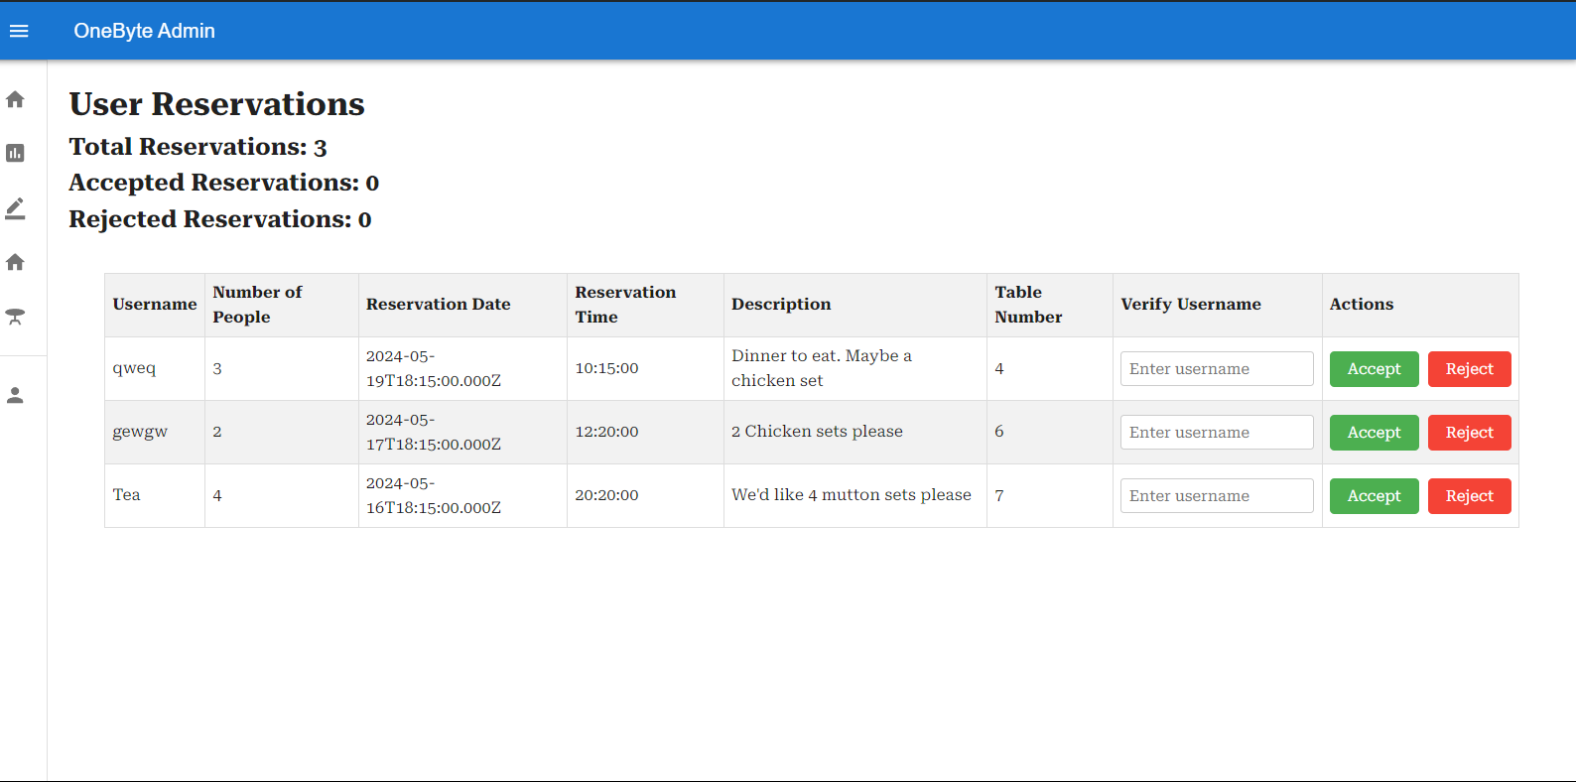

When the admin makes a choice of accept or reject there needs to be an alert message.

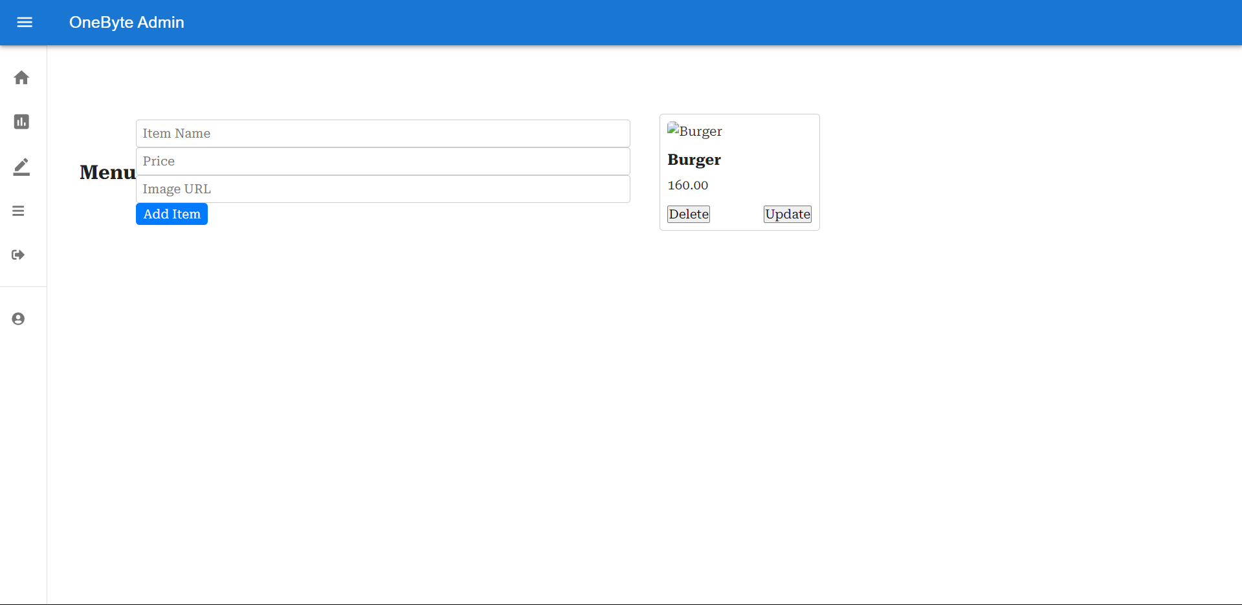

Fix the image processing.



Fix the accept and reject button, remove it completely and made sure it will add reports instead of the two buttons

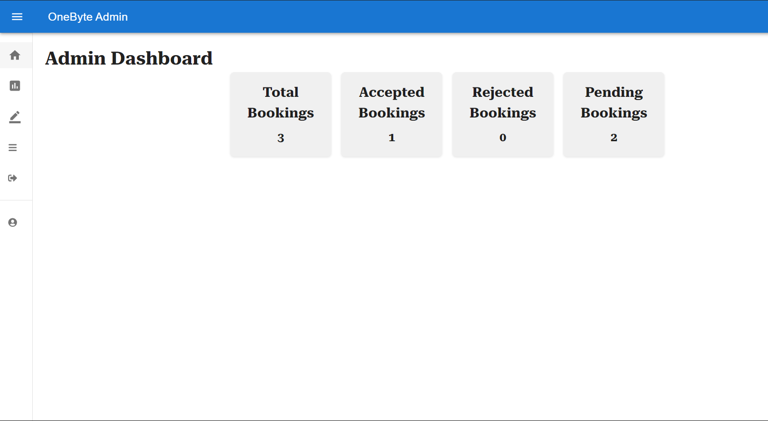

Here instead of the 4 boxes just keep the total bookings only in a big box and down below just a table which shows those bookings but cannot be edited.